The Straight line

MD. MOHIUDDIN

LECTURER, COMILLA university

2020

**Straight line**

**Locus of a Point:** A locus of a point is a path in which it moves in a plane or in a space by following the certain rules/conditions.

**Straight line:** A straight line isastraight one-dimensional figure having no thickness and extending infinitely in both directions.

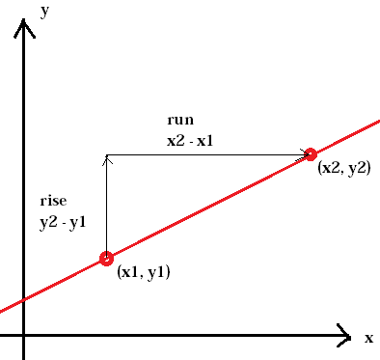**Slope:** The slope is defined as the ratio of the vertical change between two points to the horizontal change between the same two points. The slope of a line is usually represented by the letter m .If the points are  and , then the slope is defined as

.

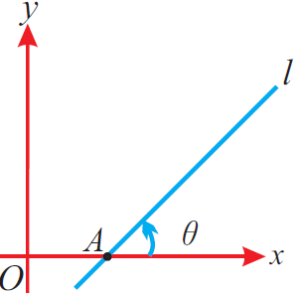Again, if a line makes an angle  with the positive direction of the x- axis, then  is called the inclination of the line and the slope is defined as,

.

**Horizontal straight line:** The equation of the horizontal line passing through the point is . Note: 1. The equation of the axis is .

2. The equation of any line parallel to axis is , where  is an unknown constant.

**Vertical straight line:** The equation of the vertical line passing through the point is . Note: 1. The equation of the axis is .

2. The equation of any line parallel to axis is , where  is an unknown constant.

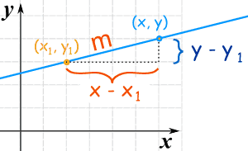**Straight line in point-slope form:** Suppose that  is a fixed point on a non-vertical line, whose slope is . Let be an arbitrary point on the line. Then by the definition, the slope of the line is given by



.

This is the equation of the straight line in point-slope form.

Note: The equation of the line passing through the origin and having slope is .

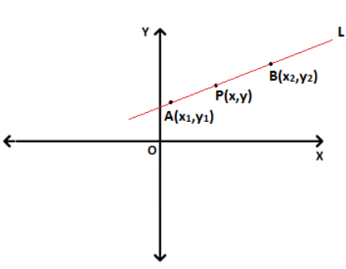**Straight line in two-point form:** Let be any point on the line other than  and . Since AP and AB are on the same line, so the slope of the line segment AP is equal to the slope of the line segment AB.



.

This is the equation of the straight line in two-point form.

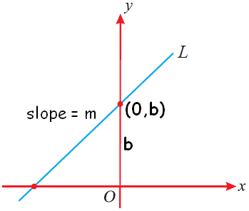**Straight line in slope-intercept form:** Suppose a line L with slope  cuts the axis at a distance b from the origin. The distance b is called the y-intercept of the line L. Obviously, the coordinate of the point where the line meet the y-axis is . Thus, the line L has slope m and passes through a fixed point . Therefore, by the point- slope form, the equation of the line L is,



.

This is the equation of the straight line in slope-intercept form.

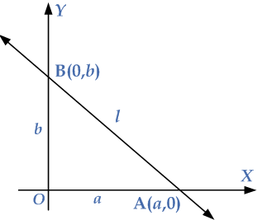**Straight line in intercept form:** Let, the x-intercept of the line is a and the y-intercept of the line is b. So, the line cuts the x-axis at  and the y-axis at . Therefore, the equation of the line passing through  and  is,



.

This is the equation of the straight line in intercept form.

**Straight line in normal form:** Let, the straight line cut the x-axis at A and the y-axis at B. Then the equation of the line in the intercept form is,



Let p be the length of the perpendicular OD from the origin  on the line (1) and let .

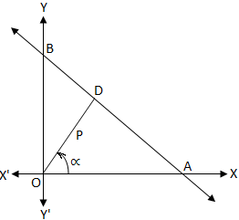.

Then from the right angled, we have



and .

So from (1), the required equation of the line is



.

This is the equation of the straight line in normal form.

**Straight line in general form:** A first degree equation in x and y represents a straight line. The equation  is called the general equation of a line.

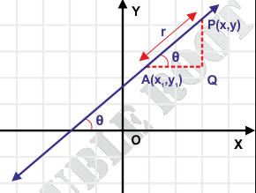**Straight line in parametric form:** If be any point on the line passing through and having inclination, then parametric equation of such line is , , where (r is a real parameter) is the distance from A to P .

**Angle between two straight lines:** Let, the two straight lines be,



and 

Let the lines (1) and (2) make the angles  and  with x-axis respectively. So the slopes of the lines are  and  respectively. But  and  are the slopes of (1) and (2) respectively, so that we have  and .

Let  be the angle between two straight lines, so from the figure we have

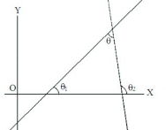 







.

This is the required angle between the lines  and .

Note: 1. The lines are parallel if i.e. .

2. The lines are perpendicular if i.e. .

If the equations of the lines are  and , then the slopes of these equations are  and  respectively. In this case, the angle between the lines is

.

These lines are parallel if  and perpendicular if .

**Distance of a point from a line:** Let, the given point be and the equation of the line  be



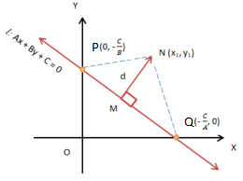 Let the distance from the point to the line  be . Draw a perpendicular MN from the point to the line . If the line meets the x-axis and y-axis at the points Q and P respectively, then the coordinates of the points are  and .

Thus, the area of the triangle NQP is given by,

Area of





Now, 



and area of 



.

From (2), we get





.

This is the required distance/ length of perpendicular from the point to the line .

**Distance between two parallel lines:** Let, the equations of two parallel lines are,

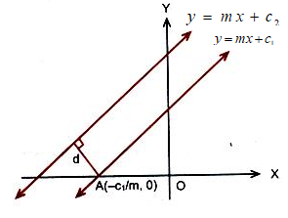

and 

Line (1) will intersect x-axis at the point .

The distance between two lines is equal to the length of the

perpendicular from the point  to the line (2).

i.e. .

Note: The distance between two parallel lines  and  is.

**Point of intersection of two straight lines:** Let us assume the equations of two given straight lines are



and 

Solving these for x and y, we have



, 

So the point of intersection of two straight lines (1) and (2) is .

**Equations of the line passing through the intersection of two lines:** Let us consider two straight lines P and Q whose equations are



and 

respectively. The equation of the line passing through these two lines is





where  is an arbitrary constant.

Area of a triangle formed by three given lines: Let us consider the equations of three given lines are





and 

The area of these three lines is given by



where , , and .

**Theorem-01:** Prove that the equation of a straight line is always of the first degree in x, y. Also its converse is true.

**Proof:** We know that through two given points, one and only one straight line can be drawn. Let  and  be two given points on the straight line and  be any point on it. Then if P is a point on the straight line, the area of the triangle PAB must be zero.

i.e. 





,

where , , .

This is the first degree equation in x, y.

Hence the equation of a straight line is always of the first degree in x, y.

**Conversely:** Every first degree equation in x, y represents a straight line. Let  be any first degree equation. Let ,  and be three points on it. Then their co-ordinates must satisfy this equation, i.e. we have



Now eliminating a, b, c from the above relations, we have

,

This is the condition for the points,  and  to be collinear. So these three points lie on a straight line, i.e. the equation  represents a straight line.

Hence the general equation of a straight line is of the form  and every first degree equation of the form  represents a straight line. (**Proved**)

**Question-01:** Find the equations of the bisectors of angles between two lines.

**Answer:** Let us assume the two given straight lines be PQ and RS whose equations are



and 

respectively, where  and  are of the same symbols.

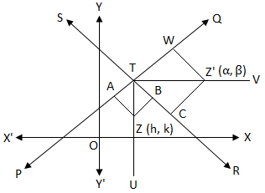Let the two straight lines PQ and RS intersect at T and  contains origin O. Again, let TV is the bisector of  and is any point on TU. Then the origin O and the point Z are on the same side of both the lines PQ and RS.

Again, let us assume that TU is the bisector of  and is any point on TU. Then the origin O and the point Z are on the same side of both the lines PQ and RS.

Therefore,  and  are of the same symbols as well as  and are also of the same symbols. Since we already assumed that  and  are of the same symbols so  and shall be of the same symbols.

Therefore, the lengths of the perpendiculars from Z upon PQ and RS are of the same symbols. Now, if  and then it implies that .

i.e. .

Therefore, the equation to the locus of is,



This is the equation of the bisector of angle containing the origin.

Again, suppose that TU is the bisector of  which does not contain the origin O and is any point on TV. Then the origin O and the point  are on the same side of the line PQ but they are on opposite sides of the straight RS.

Therefore,  and  are of the same symbols but  and are of opposite symbols. Since we already assumed that  and  are of the same symbols so  and shall be of opposite symbols.

Therefore, the lengths of the perpendiculars from  upon PQ and RS are of opposite symbols. Now, if  and then it implies that .

i.e. .

Therefore, the equation to the locus of is,



This is the equation of the bisector of angle not containing the origin.

From (3) and (4) it is seen that the equations of bisectors of the angles between the lines (1) and (2) are

. (**Solved**)

**Problem-01:** Find the equations to lines passing through  and (a) parallel (b) perpendicular to .

**Solution:** The given line is



**First part:** The equation parallel to (1) is



Since (2) passes through  so we have





Putting the value of k in (2), we have

.

This is the required equation of line passing through  and parallel to .

**Second part:** The equation perpendicular to (1) is



Since (3) passes through  so we have





Putting the value of k in (3), we have

.

This is the required equation of line passing through  and perpendicular to .

**Problem-02:** Determine the equations to the bisectors of the angle between the lines  and .

**Solution:** The given lines are



and 

If  be any point on any one of the bisectors, then the equations of the bisectors are given by





Taking (+) sign, we have

.

Taking (-) sign, we have

.

**Problem-03:** Find the area of the triangle formed by the lines , and . Also comment about the concurrency of these lines.

**Solution:** The given lines are





and 

**First part:** The determinant formed by the equations (1), (2) and (3) is defined as

.

Here 





and 

Putting these values in (4), we get

.

**Second part:** Since , so the lines do not meet at a point i.e. they are not concurrent.

**Problem-04:** Find the equation of the line which passes through the point of intersection of the lines , and perpendicular to .

**Solution:** The given lines are





and 

Any line through the point of intersection of lines (1) and (2) is defined as





If (4) is perpendicular to (3), then we have





Putting the value of  in (4), we get

.

This is the required equation of the line.

**Problem-05:** Find the equation of the line which passes through the point of intersection of the lines , and which makes equal intercepts on the axes.

**Solution:** The given lines are



and 

Any line through the point of intersection of lines (1) and (2) is defined as





The intercept form of (3) is



Since the intercepts of (4) on the axes are equal so



Putting the value of  in (3), we get

.

This is the required equation of the line.

**Problem-06:** Find the equation of the bisector of that angle between the lines  and in which the origin lies.

**Solution:** The given lines are



and 

If  be any point on the bisector in which the origin lies, then the equations of the bisector is given by









.

This is the required equation of the bisector of that angle between the given lines in which the origin lies.

**Problem-07:** Find the equations of the two straight lines passing through the point (2, 1) and inclined at angle of  with the line .

**Solution:** The given line is



The equation can be written as



The of equation (2) is . The equations of the lines, which pass through (2, 1) and make angle  with (2), are



and 

From equation (3), we have





.

From equation (4), we have





.

These are the required equations.

**Exercise:**

**Problem-01:** Find the equation of the line which passes through the point of intersection of the lines

, and satisfies the following conditions.

(a). Passes through (4,2) A ns: .

(b). Is parallel to  A ns: .

(c). Is perpendicular to  Ans: .

(d). Whose intercepts are equal Ans: .

**Problem-02:** Prove that the three straight lines , and 

concur/meet at a point.

**Problem-03:** Show that the area of the triangle formed by the straight lines , and

 is .

**Problem-04:** Find the equations of the two straight lines passing through the point (1, -3) and inclined at angle of  with the line . Ans: .